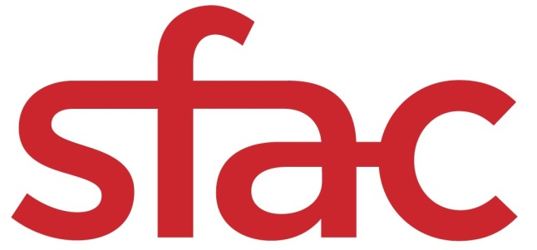
Arts Impact Endowment (AIE)
Universal Basic Income (UBI)
Application Instructions

Deadline to apply: OCTOBER 30, 2020 at 12 p.m. PST
Applications are available online at: https://sfac.tfaforms.net/66
Please visit the Universal Basic Income Guidelines to review eligibility, project requirements and scoring criteria: https://www.sfartscommission.org/content/special-project-grants-spx
For any questions about Arts Impact Endowment, please contact Deputy Director of Programs Joanne Lee at joanne.lee1@sfgov.org or 415-252-2238.
Online Submission
We strongly advise organizations to use the information in this document to prepare your application responses. Preparing them in a separate document and not the online form protects your answers from any technical mishaps such as internet interruption or power outage. Once finished, paste your completed answers into the online application when you are ready to submit.

Applicants are able to save their progress and return to the online application, as needed. To do so, complete the following steps:
- Check the “Save my progress and resume later” box at the top of the page.
- Enter an email address and password (use the same email address and password each time you exit the application) and hit “Save”.
- You will receive an email with a link that allows you to return to the application.
- OR you can return to the application website and select the “Resume a previously saved form” link.
Required Materials with Application Submission
☐ Verifiable proof of corporate address: This should be in the form of an electric or telephone bill or bank statement. Document should be no more than three (3) months old and must include applicant's name.
☐ Proof of IRS good standing: Visit IRS-Tax Exempt Organization Search: https://apps.irs.gov/app/eos/pub78Search.do. Select Database "Pub 78 Data". Search for the applicant organization EIN number or Organization Name. Select the correct organization. Save a PDF of the screen titled "Publication 78 Data" that shows your organization listed.
☐ Financial statements for the last two completed fiscal years: Audited financial statements or IRS 990, 990-EZ or 990-PF or Profit and Loss Statements and Balance Sheets for the last two (2) completed fiscal years; and budget notes.
Organization Information:
- Legal Name of Applicant Organization
- Mission Statement (500 characters)
- Core Programs and Services (1,000 characters)
- Intended Communities/Audience (1,000 characters)
- Contact Name, Title, Email Address, Phone Number
- Supplier ID Number: If you are unsure of your Supplier ID Number, please create a new ticket at https://sfcitypartner.sfgov.org/pages/contact.aspx. If you do not have a Supplier ID Number, please enter 0.

Narrative Questions:
Grant Administration Experience (20 points)
Describe your experience providing equitable grant administration programs for financially vulnerable populations. (3,000 characters)
Outreach to San Francisco Artists (20 points)
Describe your experience in conducting outreach to SF artists and cultural workers in historically marginalized communities. If you lack SF experience, describe other relevant experience. (3,000 characters)
Ability to Develop Grant Program Guidelines, Eligibility and Award Criteria
(40 points)
Describe your past experience developing grant guidelines, eligibility and award criteria, and applications that are accessible and low-barrier for historically marginalized populations, including BIPOC, immigrant, transgender and disabled populations.
Describe your capacity to produce materials and provide technical assistance in multiple languages. (4,000 characters)
Financial and Administrative Systems (20 points)
Describe your financial and administrative systems for administering and tracking monthly payments to grantees. (2,000 characters)

Project Budget
The online application requires an eighteen (18) month project budget detailing itemized expenses. For each expense, provide the name, hourly rate, and/or breakdown of costs in the "Notes" field. Each field is REQUIRED. Enter “0” if the expense is not applicable.

Download the budget template for a complete list of expenses here (Excel required): http://tiny.cc/SFAC_BudgetTemplate
Project Budget Notes
If this grant request is part of a larger project budget, please provide information on expenditures covered by other funding source(s).
Grant Plan
The Grant Plan details primary activities that will take place during the grant period (January 1, 2021 – June 30, 2022) and the intended outputs the applicant hopes to achieve. Outline six (6) activities for the grant period.

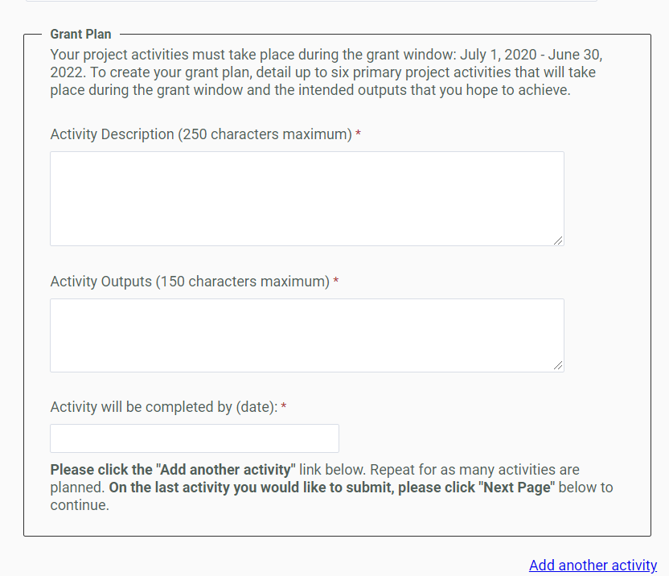

Activity Description: Each activity should be described succinctly in one sentence and clearly outline the steps needed to ensure a successful outcome. Example: Lead artist and ensemble musicians engage in work-in-progress community performances featuring traditional and Western instruments and hold community education conversations. (250 characters)
Activity Outputs: The Outputs field represents the anticipated quantitative measure for the corresponding activity. For example, this may be the number of artists compensated or the number of rehearsals or performances held. Example: Three (3) performances, three (3) community education conversations, 150 attendees. (150 characters)

Date activity will be completed: Each activity should have a targeted completion date that falls within the grant period. Example: 7/31/21.
Demographic Survey
The San Francisco Arts Commission collects demographic data about our grant applicants to better serve our communities and to maintain our commitment to equity.

Completion of this demographic survey is optional. Any data you provide will not be seen by panelists or used in the evaluation of your application. Rather, it will be used to evaluate and inform outreach and technical assistance strategies for San Francisco Arts Commission staff.

We collect demographics based on the locations of artists and organizations within San Francisco's supervisorial districts and designated Cultural Districts. For information on the boundaries of these districts, please click here: https://sfplanninggis.org/PIM/map.html?layers=Supervisor%20Districts,Cultural%20Heritage%20Districts

Finally, we understand that the criteria/categories in this survey might not be perfect, and we appreciate any feedback to revise categories in ways that may feel more appropriate.
Certification and Release
This page requires you to check the box on the release form, input your legal name and select the date you are submitting the form. It will not go through if it has a different date selected.

After you click “Submit” the form will show you all of your answers. Review it to make sure everything is complete. You can edit the form by clicking “Make a correction.” You’ll need to click through the entire form again to “Submit.”

Once you’ve reviewed everything and ensured it’s correct, choose “Print this page.” Print and save your application as a pdf for your records.

Finally, click “Confirm.” Your application is not fully complete until you click “Confirm.” You will get an email that says your application has been submitted. If you do not get this email, please contact sfac.grants@sfgov.org.
Scoring Criteria
Panelists are instructed to use the scoring criteria published on pages 7-8 of the Universal Basic Income Grant Guidelines when reviewing each application. To view the Universal Basic Income Grant Guidelines, visit: LINK

