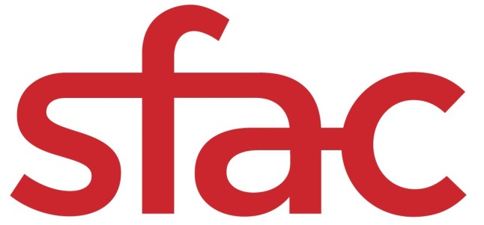
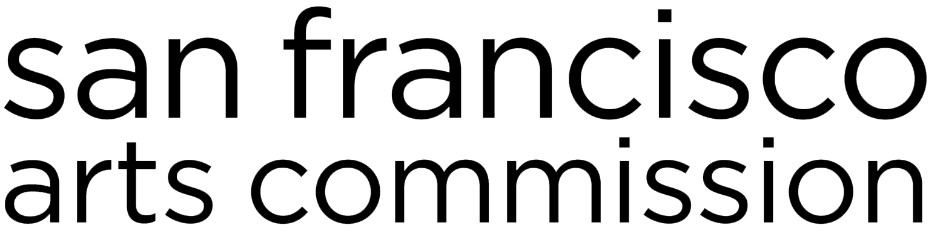

Special Project Grants | Grant Guidelines & Application
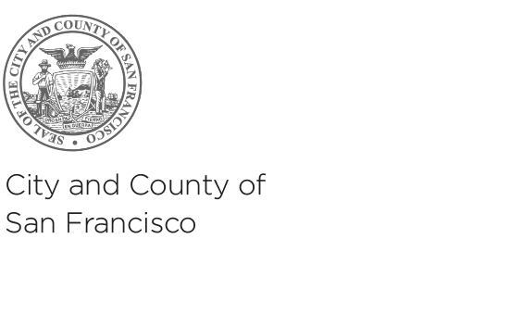
FOR PROJECTS TAKING PLACE JUNE 2019 — JUNE 2020, or as indicated.

APPLICATION DEADLINE: Monday, April 1, 2019 at 12 p.m. noon PT
(submission by email to barbara.mumby@sfgov.org)

For any questions about Special Project Grants, contact Director of Community Investments, Barbara Mumby at barbara.mumby@sfgov.org or 415-252-2215.

San Francisco Arts Commission  Tom DeCaigny  Director of Cultural Affairs  401 Van Ness Avenue, Ste. 325  San Francisco, CA 94102  tel 415-252-2590  fax 415-252-2595  sfartscommission.org  facebook.com/sfartscommission  twitter.com/SFAC | *A translation of this grant application is available upon request; however, only applications in English will be accepted. For more information, please contact 311.  Una traducción de esta solicitud de aplicación está disponible a petición; sin embargo, solamente se aceptarán solicitudes en inglés. Favor comunicarse con Kate Patterson-Murphy al 415-252-2229 ó kate.patterson@sfgov.org para una traducción al español.  本資助申請表的翻譯版本將應請求而提供；但僅受理英文版本的申請表。 查詢詳情，請聯絡311。  Ang pagsasalin sa Tagalog ng aplikasyon para sa pagkalooban na ito ay makukuha kung hihingilin. Ngunit ang aplikasyon sa Ingles lamang ang aming tatanggapin. Para sa tulong, maaring i-contact si Cece Carpio, 415-252-2217 o cece.carpio@sfgov.org.

Information about Special Project Grants (SPX)
Important Dates
Applications Due April 1, 2019, 12 NOON PT

Application Review April 5, 2019

Funding Recommendations April, 2019

Commission Approval May 6, 2019

Grant Period June 1, 2019-June 30, 2020

About SPX
The Special Project Grants (SPX) program consists of one-time grants to address emerging needs within the arts ecosystem of San Francisco. Projects cover a wide range of arts activities related to neighborhood and/or community-based engagement and arts access. SFAC has allocated resources to make grants in multiple program areas based on supervisorial districts and/or specific communities. Applicants may only apply for funding specific to those geographic areas or communities outlined within these guidelines. For questions about this grant category, please contact Director of Community Investments, Barbara Mumby at barbara.mumby@sfgov.org or 415-252-2215.
Eligible Request Amount
This Special Project Grant RFP is for one distinct project for up to $100,000.

How to Apply
Applications must be received by email no later than 12pm (noon) on Monday, April 1, 2019. In fairness to others, we cannot accept late or incomplete applications. An application may be deemed incomplete and ineligible if the applicant does not provide the complete set of information in the appropriate format by the deadline. No deadline extensions will be granted.

DEADLINE TO APPLY: 12 p.m. noon PT on Monday, April 1, 2019
Project Description
Mitigation of Emergency Space Related Needs for Arts Non-Profits: Support up to $100,000 for a non-profit intermediary organization to provide emergency grants for up to $20,000 each to arts and culture nonprofits facing permanent displacement, or those previously displaced, or with lease renewals at substantially higher rates amidst a volatile real estate market.

The emergency grants should support needs, such as: professional services (movers, architectural, engineering, legal); rent stipend; and moving expenses.

Applicants should address the following within their proposed project:
- The organization’s history and experience providing technical assistance pertaining to financial health and real estate to arts organizations in San Francisco.
- The organization’s approach to providing responsive grants in emergency situations.
- Demonstrate strong leadership and partnerships that conveys confidence that the organization is best positioned to provide the services outlined.
- An organizational budget that further indicates the future sustainability of the organization.

Who Can Apply

Eligibility
- The applicant organization must be tax-exempt under Internal Revenue Code Section 501(c) (3)
- The organization must be based in San Francisco.

- The organization’s mission statement must be clearly focused on increasing the financial resilience and sustainability of community-based nonprofits.

- The applicant organization cannot be part of another City agency or department.

- Applicants must not be in default on any grants or loans from: (1) SFAC, (2) other City departments (including, without limitation, the Department of Children, Youth, and their Families; Office of Economic and Workforce Development; Mayor’s Office of Housing and Community Development; and Grants For The Arts), (3) Northern California Grantmakers Arts Loan Fund; (4) Northern California Community Loan Fund, (5) Community Arts Stabilization Trust; or (6) the Center for Cultural Innovation. This default clause was expanded due to the fact that SFAC has a fiduciary relationship with these particular organizations, through either shared City resources or other pooled philanthropic funds.
- The proposed project must take place in San Francisco between June 1, 2019 and June 30, 2020.
- The organization must be willing and able to meet the requirements associated with receiving funds from the City and County of San Francisco. In order to receive a grant from the San Francisco Arts Commission, you must become a registered, compliant supplier (formerly called a vendor) and meet the City of San Francisco's insurance and business tax requirements. For more information about vendor requirements, visit: http://sfgov.org/oca/qualify-do-business. Please note if you are not already a City supplier, you will only be required to register if you are awarded a grant. Insurance and business tax requirements will be explained and made available upon approval of grant awards.

Restrictions
- A proposed project cannot receive simultaneous funds from multiple SFAC funding sources; this includes collaborators applying to work on different components of the same project and applying separately.
- Applicants cannot submit more than one application.
- Grant funds may not pay for:
- Activities outside of San Francisco;
- Deficit reduction;
- Start-up money for new organizations;

Grantee Requirements
- City Permits and Permissions: If the proposal includes components that require City permits or approval such as publicly installed art, street closures, sound amplification in public space, or murals, the artist will be solely responsible for securing the necessary permits, permissions, insurance, and approvals. This planning should be reflected in your project timeline.
- Insurance Requirements:
General Liability: Awarded grantees will need to submit a certificate of General Liability Insurance and an Endorsement Page with first invoice. General liability insurance cannot be waived. This requirement can met by the following:
  - Purchasing General Liability Insurance as an individual artist or organization.
  - Purchasing Special Event Insurance for any public events associated with the grant project.
  - Obtaining a General Liability Insurance certificate from their host venue, which adds the grantee and event to their policy by endorsement and lists the San Francisco Arts Commission as additionally insured.
Workers Comp Insurance: Workers Comp insurance is required for an organization that has employees. If you do not have employees, the San Francisco Arts Commission will provide a waiver for this requirement.
NEW: Waiver of Subrogation addendum is required for organizations to do work on ANY City-owned property.

Auto Insurance: Auto Insurance is required if the awarded grantee will use a vehicle for the purposes of the grant. The San Francisco Arts Commission will provide a waiver for this requirement.

Abuse and Molestation Insurance: Proof of Abuse & Molestation coverage in addition to General Liability coverage is required for working with vulnerable populations (minors, disabled people, or elderly people).
- Art Installation: Please note that any art installed with these grant funds on property owned by the City and County of San Francisco or on private property, must be reviewed and approved by the San Francisco Arts Commission starting with the Visual Arts Committee of the Commission. This applies to murals, public sculpture, and similar projects. It will be the responsibility of the grantee to build this process into their grant plan and timeline. Please contact the following Public Art Program staff if you have questions: Alyssa Torres at alyssa.torres@sfgov.org for murals.
Panel Evaluation and Scoring Criteria
Grants Panelists
Special Project grant applications are evaluated in a closed panel review process by SFAC staff and partners. Grant review panelists will have experience that aligns with the purpose of the specific grant category.

Scoring Criteria
Panelists will be instructed to use “Fund” or “Not Fund” when reviewing applications.
The review panel will assess all applications and will recommend a single grant for the applicant that most strongly meets the review criteria below. The panel's review of applications and required documents is a multi-step process and involves assigning applications as “Fund” or “Not Fund”. Applications must be assigned a “Fund” by the review panel to be considered for funding.

History and Merit
- The organization demonstrates a long-standing and deep connection to the arts community.
- Demonstrates the provision of ongoing and responsive support to the needs of marginalized communities.

Impact
- The organization has had a profound impact on sustaining the broader arts ecosystem.

Application Review
Grantees will be selected by a staff review process comprised of representatives from the San Francisco Arts Commission and other City department staff or funding partners. Panelists will review applications and make funding recommendations. Priority will be given to applicants who successfully meet the criteria within each funding category.

Panel Review Attendance
SPX panels are not open to the public. Please note an applicant that is found to have made attempts to influence a panelist in any way will be automatically disqualified.

Funding Recommendations
Based on an evaluation of the proposals, panelists assign applications as “Fund” or “Not Fund” for funding recommendations for each category. Applications that do not have “Fund” assigned will not be eligible for funding. Grant amounts are either the full amount of the grant sought or a substantial portion of the requested grant—and never less than 75 percent.

Panel Notes
Panelists may take notes during their review. You may contact sfac.grants@sfgov.org to obtain panel comments.

Funding Approval
Panel recommendations are subject to the approval of the Arts Commission. Typically, recommendations are first reviewed by the Community Investments Program Committee, then by the full Commission. Meetings of the Commission are public. The agenda will be available on the Arts Commission website at sfartscommission.org 72 hours in advance of the meeting.

Grant Awards
Grant award notifications will be emailed following Commission approval and include instructions about contracting procedures.

Application
In a separate word document, please answer the following questions and email to barbara.mumby@sfgov.org no later than 12 noon on Monday, April 1, 2019:

- List the applicant organization’s name, address and
primary contact information.

- Provide the Mission Statement of the applicant
organization.

- Describe the history of the applicant organization.
(700 words or less)

- Provide an overview of the applicant organization’s ongoing applicable services. (700 words or less)

- Describe how these funds will be used to mitigate
emergency space issues for arts non-profits. (300 words or less)

- Attach a copy of the applicant organization’s current
balance sheet and YTD Profit and Loss statement.

