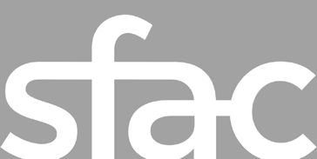
Individual Artist Commission (IAC) Application Instructions
How to Prepare and Submit your Application
Grant Plan Screenshot amended 10/29/19
Deadline to apply: Wednesday, November 13, 2019 at 12 p.m. NOON PST
Applications are available online at: https://sfac.tfaforms.net/29
Please visit: the Individual Artist Guidelines to review eligibility, project requirements and scoring criteria: http://tiny.cc/IACGuidelines
For questions about this grant, please contact Program Officer Anne Trickey at anne.trickey@sfgov.org or 415-252-2213.

Application Submission
We strongly advise applicants to use the information in this document to prepare their application responses in a separate document. Applicants should paste their completed answers into the online application when they are ready to submit.

Applicants are able to save their progress and return to the online application, as needed. To do so, complete the following steps:
- Check the “Save my progress and resume later” box at the top of the page.
- Enter an email address and password (use the same email address and password each time you exit the application) and hit “Save”.
- You will receive an email with a link that allows you to return to the application.
- OR you can return to the application website and select the “Resume a previously saved form” link to return to the application.
Required Materials with Application Submission
☐ Verifiable proof of San Francisco address: This may be in the form of an electric or telephone bill or bank statement. This document should be no more than three (3) months old and must include the applicant's name.
Required Information for Fiscally Sponsored Applicants:
- Legal name of Fiscal Sponsor Organization
- Fiscal Sponsor Organization executive leader’s name, phone number, and email address
- Fiscal Sponsor’s mailing address
- Signed Fiscal Sponsor Form between the Applicant Organization and the Fiscal Sponsor Organization. Fiscal Sponsor form downloadable here: https://tinyurl.com/SFAC-FiscalSponsorForm

Application Questions and Project Requirements
Applicant Information:
- Legal Name of Applicant
- Artist Name (if different from an applicant’s legal name)
- Artist Pronouns
- Artist Home Address, Phone Number and Email Address
- Mailing Address (if different)
- Supervisor's District Number of your home address
- Supplier ID Number: If you are unsure of your Supplier ID Number, please create a new ticket at https://sfcitypartner.sfgov.org/pages/contact.aspx. If you do not have a Supplier ID Number or are using a Fiscal Sponsor, please enter 0.

Project Information:
- Grant request amount (up to $20,000)
- Provide a brief summary of the proposed project that starts with "San Francisco Arts Commission funds will be used to support" (600 characters)
- Project discipline (dropdown menu, Dance, Music, or Theater)
- Native American Arts and Cultural Traditions Review? (yes/no)

Application Questions:
- Describe the community in which you are deeply rooted and involved. (3,000 characters)
- Tell us about your experience relevant to your project. (1,500 characters)
- Provide a brief bio (500 characters)
- Describe the ideas and processes involved in making your project. (3,000 characters)

- Does this project include working with other artists? (yes/no)

  - If you are working with other artists, please describe their role. (500 characters)
- Please tell us about your public event including: date and location, who you are inviting and how you are inviting them; and how you will know the event was a success. (1,500 characters)

- How will this project advance, affect, or move your artistic practice in a meaningful way? (2,000 characters)

☐ Grant Plan
The Grant Plan outlines five (5) primary activities that take place during the grant period (July 1, 2020 – June 30, 2021) and includes the intended outputs the applicant hopes to achieve.

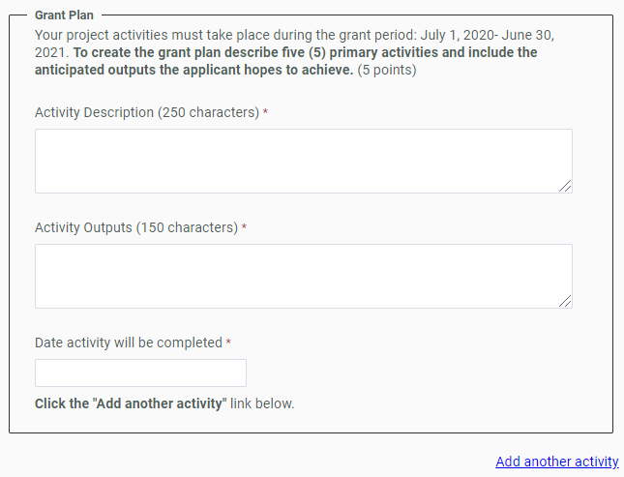

Activity Description (250 characters): Each activity should be described succinctly in one sentence and clearly outline the steps needed to ensure a successful outcome. Example: Artist performs work-in-progress featuring traditional instruments.
Activity Outputs (150 characters): The Outputs field represents the anticipated quantitative measure for the corresponding activity. For example, this may be the number of artists compensated or the number of rehearsals or performances held. Example: 3 performances, 3 community public conversations, 150 attendees.

Date activity will be completed: Each activity should have a targeted completion date that falls within the grant period. Example: 12/31/20.
Project Requirements:
☐ Artistic Work Samples: Upload up to five (5) samples of artistic work providing evidence of the ability to complete the proposed project. Images, audio, and video (links) should be from the last two (2) years.

☐ Two-Page Resume or Curriculum Vitae (CV): Panelists review this along with the artist bio and experience relevant to the proposed project. If the document is longer than two pages, only the first two pages will be reviewed.
☐ Venue Confirmation Form: Attach a signed Venue Confirmation Form for the proposed public presentation site. Venue Confirmation form downloadable here: http://tiny.cc/SFACVenueConfirmation.
Scoring Criteria
Panelists are instructed to use the scoring criteria published on pages 8-9 of the Individual Artist Commission Guidelines when reviewing each application. To view the Individual Artist Commission Guidelines, visit: http://tiny.cc/IACGuidelines

