Special Project Grants (SPX) Application Instructions
How to Prepare and Submit your Application
Deadline to apply: Wednesday, June 24, 2020 at 12 p.m. NOON PST
Applications are available online at: https://sfac.tfaforms.net/37
Please visit the Special Project Grant Guidelines to review eligibility, project requirements and scoring criteria.
For any questions about Special Project Grants, please contact Senior Program Officer, Jaren Bonillo at jaren.bonillo@sfgov.org or 415-252-2227.
Application Submission
We strongly advise applicants to use the information in this document to prepare their application responses in a separate document. Applicants should paste their completed answers into the online application when they are ready to submit.

Applicants are able to save their progress and return to the online application, as needed. To do so, complete the following steps:
- Check the “Save my progress and resume later” box at the top of the page.
- Enter an email address and password (use the same email address and password each time you exit the application) and hit “Save”.
- You will receive an email with a link that allows you to return to the application.
- OR you can return to the application website and select the “Resume a previously saved form” link to return to the application.
Required Materials with Application Submission
☐ Verifiable proof of San Francisco corporate address: This may be in the form of an electric or telephone bill or bank statement. Document should be no more than three (3) months old and must include applicant's name.
☐ Proof of IRS good standing: Visit IRS-Tax Exempt Organization Search: https://apps.irs.gov/app/eos/pub78Search.do Select Database "Pub 78 Data". Search for the applicant organization EIN number or Organization Name. Select the correct organization. Save a PDF of the screen titled "Publication 78 Data" that shows your organization listed.
☐ Financials: IRS 990, 990-EZ or 990-PF from the last completed fiscal year OR for fiscally sponsored applicants: Profit and Loss Statements and Balance Sheets for the last two (2) completed fiscal years; and budget notes.
Required Information for Fiscally Sponsored Applicants:
- Legal name of Fiscal Sponsor Organization
- Fiscal Sponsor Organization executive leader’s name, phone number, and email address
- Fiscal Sponsor’s mailing address
- Signed Fiscal Sponsor Form between the Applicant Organization and the Fiscal Sponsor Organization. Fiscal Sponsor form downloadable here: https://tinyurl.com/SFAC-FiscalSponsorForm

Application Questions and Project Requirements
Organization Information:
- Legal Name of Applicant Organization
- Mission Statement (500 characters)
- Core Programs and Services (1,000 characters)
- Intended Communities/Audience (1,000 characters)
- Contact name, title, email address, phone number
- Number of the Supervisor's District in which your organization operates
- Supplier ID Number: If you are unsure of your Supplier ID Number, please create a new ticket at https://sfcitypartner.sfgov.org/pages/contact.aspx. If you do not have a Supplier ID Number, please enter 0.

Application Questions:
- Provide a brief Project Summary (600 characters)
- Highlight your organization’s activities over the last two (2) years engaging with historically marginalized communities. (1,000 characters)
- Describe how the proposed project will enhance the organization’s ability to engage the intended audience/communities. (2,000 characters)
- Describe the proposed project in detail referring to the SPX Guidelines for specific elements to address. (3,000 characters)
- Provide brief bios of key project staff (up to five) and include relevant experience and qualifications. (1,000 characters)
- Describe how you will evaluate the success of the project. (2,000 characters)

☐ Project Budget*
The online application requires a project budget detailing itemized expenses. For each expense, provide the name, hourly rate, and/or breakdown of costs in the "Notes" field. Each field is REQUIRED. Enter “0” if the expense is not applicable.
Download the budget template for a complete list of expenses here (Excel required): http://tiny.cc/SFAC_BudgetTemplate

Project Budget Notes: If this grant request is part of a larger project budget, please provide information on expenditures covered by other funding source(s).
☐ Grant Plan
The Grant Plan outlines up to six (6) primary activities that will take place during the grant period (July 1, 2020 – June 30, 2021) and the intended outputs the applicant hopes to achieve.

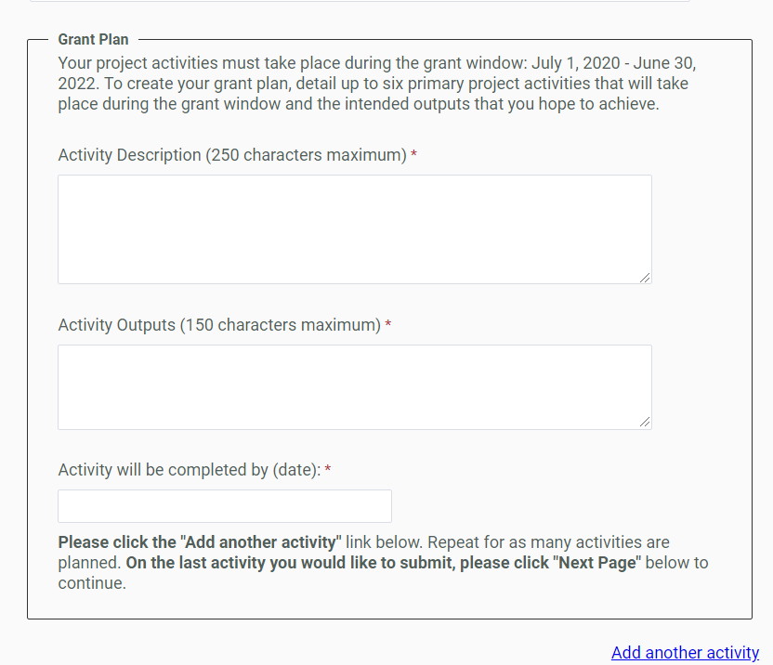

Activity Description (250 characters): Each activity should be described succinctly in one sentence and clearly outline the steps needed to ensure a successful outcome. Example: Lead artist and ensemble musicians engage in work-in-progress community performances featuring traditional and Western instruments and hold community education conversations.
Activity Outputs (150 characters): The Outputs field represents the anticipated quantitative measure for the corresponding activity. For example, this may be the number of artists compensated or the number of rehearsals or performances held. Example: 3 performances, 3 community education conversations, 150 attendees.

Date activity will be completed: Each activity should have a targeted completion date that falls within the grant period. Example: 2/31/20.

