The Sankofa Initiative (SPX) Application Instructions
How to Prepare and Submit your Application

(Amended 9/8/2020)
Deadline to apply: Tuesday, September 29, 2020 at 12:00 p.m. PST
Applications are available online at: https://sfac.tfaforms.net/61
Please visit Special Grant Sankofa Initiative Guidelines to review eligibility, project requirements and scoring criteria: https://www.sfartscommission.org/content/sankofa-initiative-spx
For questions about this grant, please contact Program Officer Tina Wiley at tina.wiley@sfgov.org or 415-252-2218.

Application Submission
We strongly advise applicants to use the information in this document to prepare their application responses in a separate document. Applicants should paste their completed answers into the online application when they are ready to submit.

Applicants are able to save their progress and return to the online application, as needed. To do so, complete the following steps:
- Check the “Save my progress and resume later” box at the top of the page.
- Enter an email address and password (use the same email address and password each time you exit the application) and hit “Save”.
- You will receive an email with a link that allows you to return to the application.
- OR you can return to the application website and select the “Resume a previously saved form” link to return to the application.
Required Materials with Application Submission
☐ Verifiable proof of San Francisco corporate address: This may be in the form of an electric or telephone bill or bank statement. Document should be no more than three (3) months old and must include applicant's name.
☐ Proof of IRS good standing: Visit IRS-Tax Exempt Organization Search: https://apps.irs.gov/app/eos/pub78Search.do Select Database "Pub 78 Data". Search for the applicant organization EIN number or Organization Name. Select the correct organization. Save a PDF of the screen titled "Publication 78 Data" that shows your organization listed.
☐ Financials: (1) IRS 990, 990-EZ or 990-PF from the last completed fiscal year; and (2) Profit and Loss Statement and Balance Sheet for the last completed fiscal year; and budget notes.
Application Questions and Project Requirements
☐ Organization Information:
- Legal Name of Applicant/Organization
- Mission Statement (100 words)
- Contact name, title, email address, phone number
- Number of the Supervisor's District in which your organization operates
- Supplier ID Number: If you are unsure of your Supplier ID Number, please create a new ticket at https://sfcitypartner.sfgov.org/pages/contact.aspx. If you do not have a Supplier ID Number, please enter 0.

☐ Application Questions and Review Criteria:
- Select which Project Area you’re applying to:
  - Cultural Preservation
  - Technology and Supplies Access
  - Professional Development
- Provide a brief project summary. (150 words)
- Grant amount requested
Cultural Significance (50 points)
- (25 points) 1. Highlight your organization’s activities over the last two years collaborating with BIPOC (Black/Indigenous/People of Color) communities.
300 word limit.
- (25 points) 2. Who is your intended audience(s) for the re-granting program? Describe your strategy for promotion and recruitment. 300 word limit.
Ability to Administer Awards (50 points)
- (15 points) 3. Identify the Project Area and describe how you will administer the re-granting program. How you will measure success? How does the Project Area relate to your organization’s history and/or mission? 350 word limit.
Project Areas:
  - Cultural Preservation: Support up to $225,000 for an art/culture-based nonprofit to administer funds to support practices and traditions from culture bearers, community historians, elders, and artists living in San Francisco.
  - Technology and Supplies Access: Support up to $250,000 for an education, youth development, or technology/media-based nonprofit to administer funds to acquire art supplies and equipment including tablets, laptops, online services, and software enabling communities and individuals to provide high quality arts experiences.
  - Professional Development: Support up to $225,000 for a youth development or workforce development nonprofit to generate and provide opportunities for community members to attend webinars, workshops, training, and events to develop skills for remote work, education in the arts, healing and wellness.
- (10 points) 4. Describe your proposed application development and selection process for the re-granting program. How will reviewers be selected and what will their qualifications be? How many awards do you anticipate distributing and how will you determine the amount of each award? 350 word limit.
- (15 points) 5. Identify the staff members who will administer the re-granting program and their relevance to the identified communities by providing brief biographies. 150 words per bio.

  - Describe your staff’s capacity and experience to support award recipients from the application through the final report. Consider some award recipients may not have regular access to technology or basic computer literacy. 300 word limit.
- (10 points) 6. What are your aspirational goals or objectives for administering the re-granting program? Describe how you will prioritize communities of color most effected by COVID-19. 300 word limit.

☐ Grant Plan
The Grant Plan outlines up to six (6) primary activities that will take place during the grant period (January 1, 2021 – June 30, 2022) and the intended outputs the applicant hopes to achieve.

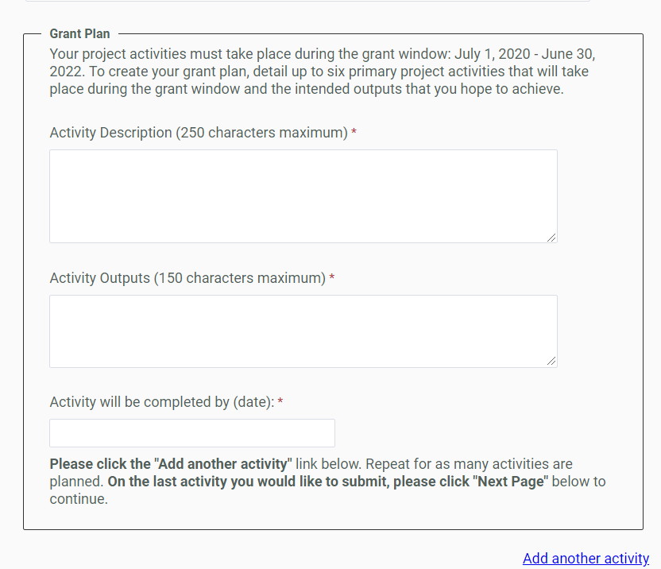

Activity Description (100 words): Each activity should be described succinctly in one sentence and clearly outline the steps needed to ensure a successful outcome. Example: Lead artist and ensemble musicians engage in work-in-progress community performances featuring traditional and Western instruments and hold community education conversations.
Activity Outputs (100 words): The Outputs field represents the anticipated quantitative measure for the corresponding activity. For example, this may be the number of artists compensated or the number of rehearsals or performances held. Example: 3 performances, 3 community education conversations, 150 attendees.

Date activity will be completed: Each activity should have a targeted completion date that falls within the grant period. Example: 12/31/2021.

The 6th or last grant activity is:
Activity: Submit SFAC Final Report
Output: 1 Final Report
Date completed by: 7/30/2022

☐ Project Budget* The online application requires a project budget detailing itemized expenses. For each expense, provide the name, hourly rate, and/or breakdown of costs in the "Notes" field. Each field is REQUIRED. Enter “0” if the expense is not applicable.

Download the budget template for a complete list of expenses here (Excel required): http://tiny.cc/SFAC_BudgetTemplate
☐ Project Budget Notes: If this grant request is part of a larger project budget, please provide information on expenditures covered by other funding source(s).
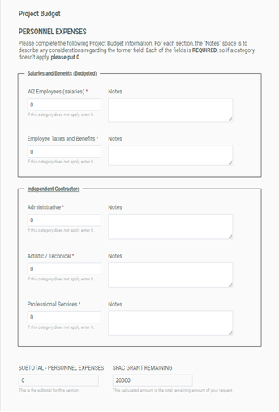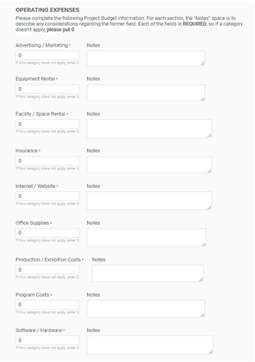

Scoring Criteria
Panelists are instructed to use the scoring criteria published on page 9-10 of the Sankofa Initiative Guidelines when reviewing each application. Please visit Sankofa Initiatives Guidelines to review eligibility, project requirements and scoring criteria: https://www.sfartscommission.org/content/sankofa-initiative-spx

